Appendix 5: Detailed description of VEMO, the Veterinary Epidemiology Metadata Ontology
- High-Level Ontology Architecture
At the top level, VEMO is relatively simple and follow the structure of the guidelines presented in the paper. It is therefor made of three main parts:
- General Metadata (related to Appendix 1) - The basic information such as title, who made it, when, what format, etc.
- General Data Description (related to Appendix 2) - The context: why was this data collected, what area and time does it cover
- Specific Content Description (related to Appendix 3) - The details: what tables exist, what columns, what are the quality issues
The `vemo:hasPart` property connects the Dataset to each of these three sections (see Figure 1).
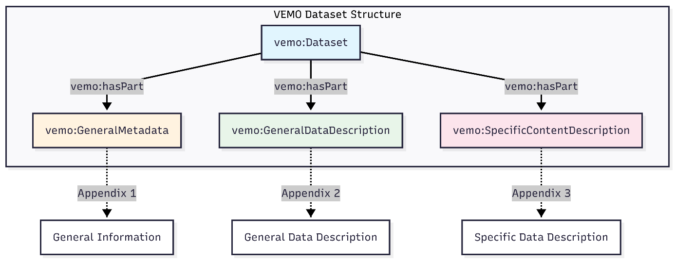
Figure 1: High-level of VEMO ontology architecture
- Class Hierarchy with External Alignments
VEMO classes are built on top of existing standards:
- DCAT (Data Catalog Vocabulary) (Data Catalog Vocabulary (DCAT) 2024) was used for describing datasets. Our `vemo:Dataset` extends `dcat:Dataset`.
- PROV-O (Provenance Ontology) (Lebo et al. 2013; Groth and Moreau 2013) was used for tracking where data came from. Our `vemo:Agent` and `vemo:Provenance` build on this.
- Dublin Core Terms (Dublin CoreTM Metadata Initiative, n.d.) was used for basic metadata like locations and time periods.
- Simple Knowledge Organisation System (SKOS) (“SKOS Simple Knowledge Organization System - Home Page,” n.d.) was used for controlled vocabularies. Our catalogues (like SPECIES, SAMPNT) are SKOS concept schemes.
- Data Quality Vocabulary (DQV) (Albertoni and Isaac 2016) was used for quality metrics. This was the big fix in v0.2.
- Friend Of A Friend ontology (FOAF) (Ruttenberg and Ciccarese 2010) was used for describing people and organizations.
- Ontology for Biomedical Investigations (OBI) (Bandrowski et al. 2016) was used for data elements (variables/attributes).
Figure 2 summarizes the different classes included in VEMO and how they align with existing standards. Complete representation of the Object and Data properties are presented in Figures 3 and Table 1 respectively. The details of these éléments are presented in the following sections.
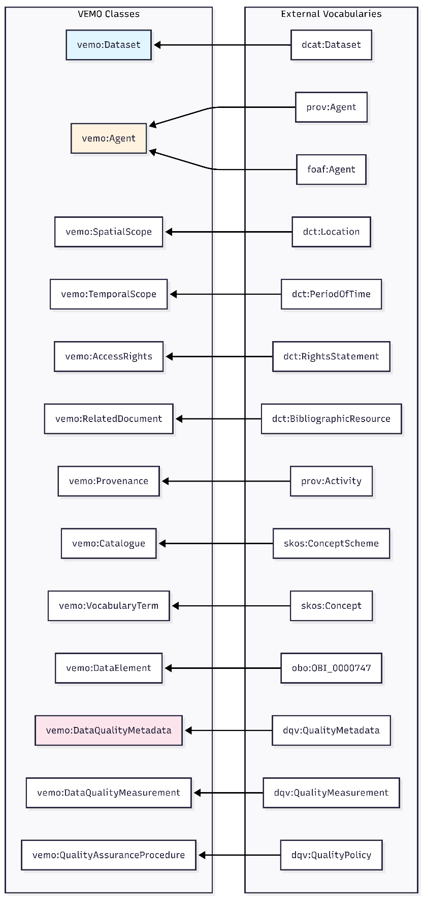
Figure 2: Class hierarchy with external alignment of VEMO
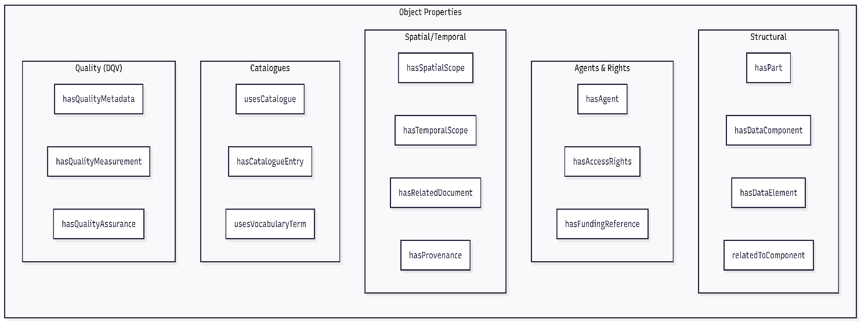
Figure 3 : Complete object properties of VEMO
Table 1 Complete data properties of VEMO
Property | Domain | Range | Appendix each item relates to
datasetTitle | GeneralMetadata | xsd:string | 1
uniqueIdentifier | GeneralMetadata | xsd:string | 1
publicationDate | GeneralMetadata | xsd:date | 1
datasetSize | GeneralMetadata | xsd:string | 1
datasetVersion | GeneralMetadata | xsd:string | 1
datasetLanguage | GeneralMetadata | xsd:string | 1
keyword | GeneralMetadata | xsd:string | 1
dataFormat | GeneralMetadata | xsd:string | 1
domainDescription | General Data Description | xsd:string | 2
originalPurpose | General Data Description | xsd:string | 2
scope | General Data Description | xsd:string | 2
subjectUnit | General Data Description | xsd:string | 2
spatialResolution | General Data Description | xsd:string | 2
temporalResolution | General Data Description | xsd:string | 2
updateFrequency | General Data Description | xsd:string | 2
numberOfEntries | General Data Description | xsd:integer | 2
newRecordsPerUpdate | General Data Description | xsd:string | 2
collectionMethod | Provenance | xsd:string | 2
processingSteps | Provenance | xsd:string | 2
componentName | DataComponent | xsd:string | 3
componentDescription | DataComponent | xsd:string | 3
relationshipDescription | DataComponent | xsd:string | 3
attributeName | DataElement | xsd:string | 3
attributeLabel | DataElement | xsd:string | 3
attributeDefinition | DataElement | xsd:string | 3
dataType | DataElement | xsd:string | 3
unit | DataElement | xsd:string | 3
missingValueCode | DataElement | xsd:string | 3
changeLogEntry | SpecificContentDescription | xsd:string | 3
businessRule | QualityAssuranceProcedure | xsd:string | 3

- Detailled description of VEMO

  - Part 1 – General Information
As shown in Figure 4, the General metadata section captures all the essential identification and administrative details when cataloging any research dataset. It starts with the basics like the dataset's title and unique identifier (typically a DOI), then covers the people involved, who created it, who published it, and who else contributed. It also includes versioning information and publication dates so users know exactly which iteration they're looking at and when it was released. The technical specifications are here too, for examples: what format the data comes in (CSV, JSON, RDF, etc.), what language it's written in, and how large the files are. Keywords help with discoverability, while funding references acknowledge the research grants that made the work possible. Finally, access rights spell out the licensing terms and any restrictions on who can use the data and how.
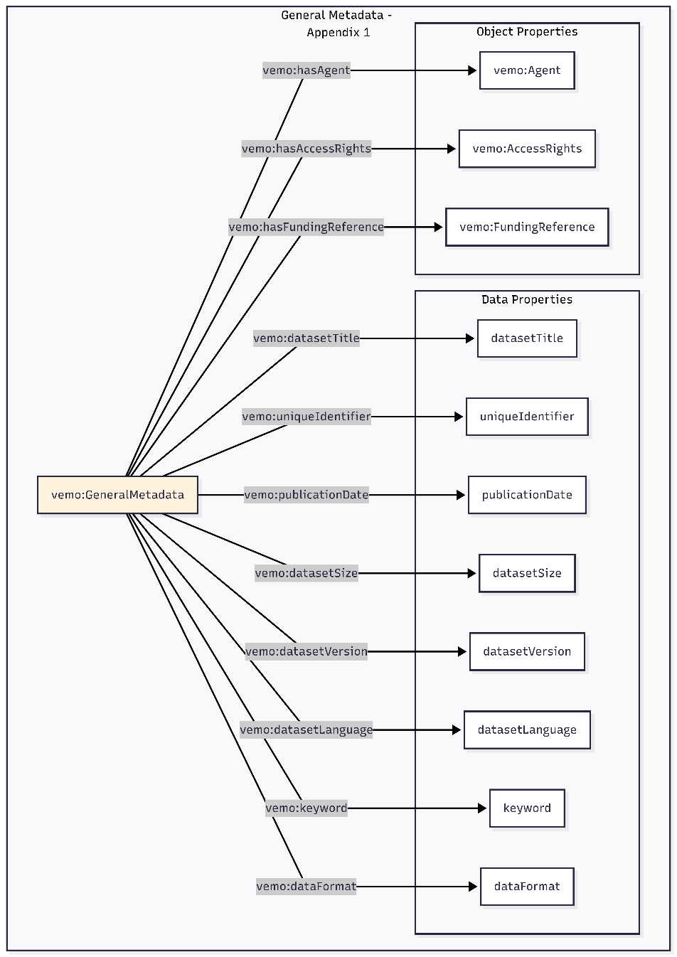
Figure 4: Properties of the General Metadata Section of VEMO

Here we use data properties for simple text or numeric values (like title, size, or version number) and object properties when linking to something more complex—for instance, an Agent representing a person or organization with their own set of details like name, affiliation, and contact information.
The different items of the General Information section and mapping with existing standards are presented in Table 2.
Table 2: Mapping of the properties associated with the General information section
Metadata Item | VEMO Property | Type | Range | Aligned To
Title | vemo:datasetTitle | DataProperty | xsd:string | dct:title
Unique identifier | vemo:uniqueIdentifier | DataProperty | xsd:string | dct:identifier
Creators | vemo:hasAgent | ObjectProperty | vemo:Agent | prov:wasAttributedTo
Publisher | vemo:hasAgent | ObjectProperty | vemo:Agent | -
Contributors | vemo:hasAgent | ObjectProperty | vemo:Agent | -
Access conditions | vemo:hasAccessRights | ObjectProperty | vemo:AccessRights | dct:rights
Publication date | vemo:publicationDate | DataProperty | xsd:date | dct:issued
Funding reference | vemo:hasFundingReference | ObjectProperty | vemo:FundingReference | -
Size | vemo:datasetSize | DataProperty | xsd:string | dct:extent
Version | vemo:datasetVersion | DataProperty | xsd:string | -
Language | vemo:datasetLanguage | DataProperty | xsd:string | dct:language
Keywords | vemo:keyword | DataProperty | xsd:string | dcat:keyword
Format | vemo:dataFormat | DataProperty | xsd:string | dct:format

  - Part 2 – General Data Description
This section answers the question: "What is this data actually about?" Someone looking at the data needs to understand why it exists, was it collected for research, for invoicing, for regulatory compliance? For example, a dataset might have been originally created for monitoring broiler health in commercial farms. They also need to know what's included: the scope might cover only poultry in Poland from 2020-2023, or perhaps cattle across all of Europe. The resolution matters too; is each row representing a single animal, a farm visit, or an entire region? Are these daily observations or monthly summaries? For example, a dataset might have farm-level records updated weekly. Finally, The provenance of the data, or data lineage, tells you how data was collected (for example through veterinary inspections or farmer self-reporting) and what processing steps were applied before you see it. This last item is made of different subcomponents presented in Figure 5.
The different items of the General Data Description section are presented in Figure 5 and Table 3
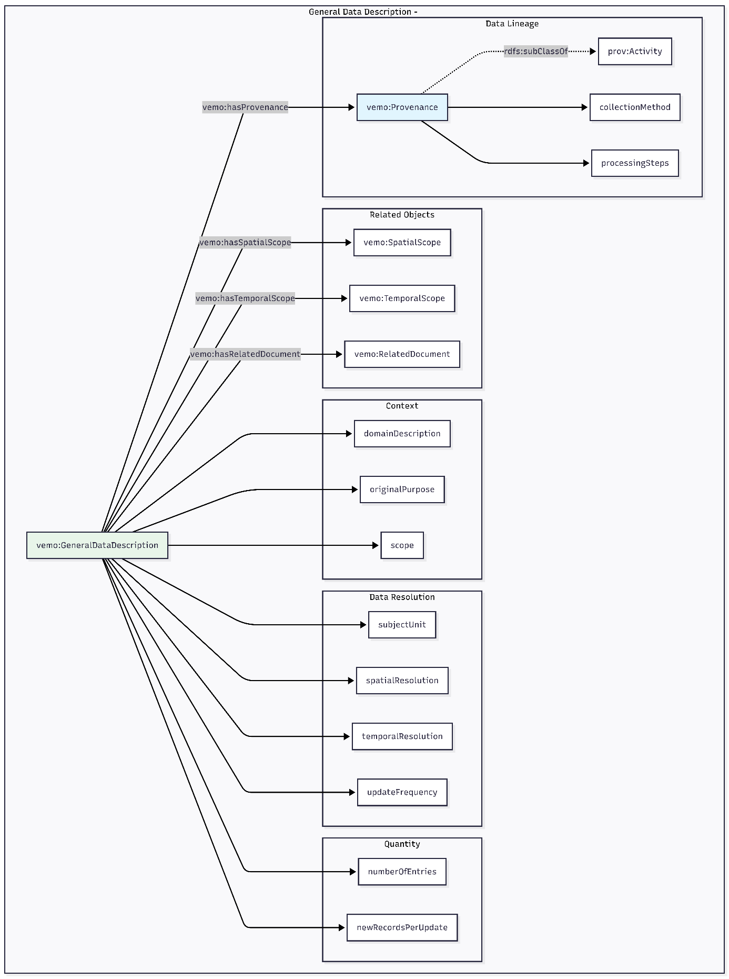
Figure 5: Properties of the General Data Description section of VEMO
Table 3: Mapping of the Properties associated with the General Data Description section of VEMO
Metadata Item | VEMO Property | Type | Aligned To
Domain | vemo:domainDescription | DataProperty | -
Original purpose | vemo:originalPurpose | DataProperty | -
Scope | vemo:scope | DataProperty | -
Related documents | vemo:hasRelatedDocument | ObjectProperty | dct:relation
Subject unit | vemo:subjectUnit | DataProperty | -
Spatial scope | vemo:hasSpatialScope | ObjectProperty | dct:spatial
Spatial resolution | vemo:spatialResolution | DataProperty | -
Temporal resolution | vemo:temporalResolution | DataProperty | -
Period covered | vemo:hasTemporalScope | ObjectProperty | dct:temporal
Update frequency | vemo:updateFrequency | DataProperty | -
Number of entries | vemo:numberOfEntries | DataProperty | -
New records per update | vemo:newRecordsPerUpdate | DataProperty | -
Data collection process | vemo:collectionMethod | DataProperty | -
Data processing steps | vemo:processingSteps | DataProperty | -

  - Part 3 – Specific Content Description
The Specific Content Description (Appendix 3) captures the detailed structure of the dataset. This includes data components, data elements, and catalogues, which are provided in Figure 6a. First, a dataset often has multiples components of tables. For example: A population table with farm/animal information and a laboratorytest table with test results. These tables relate to each other (i.e., the laboratory tests of the laboratorytest table reference animals from the population table). Then, each column within each component, or table, of the data, needs its own documentation in order for the users to understand what it is called, what it means, and what type of values it has. For columns with controlled vocabularies (e.g., "species" which can only be Cattle, Pig, etc.), they can be linked to existing Catalogues that list the allowed values. Details of the properties attached to the Data Element of VEMO are presented in Table 1.
A critical part of the specific content description is related to the description of the quality of the data. In VEMO this property has been integrated with DQV using the following rules :
- Category: A broad grouping (vemo: VeterinaryDataQualityCategory, a dqv: Category)
- Dimensions: Aspects of quality (Completeness, Correctness, Reliability - all dqv:Dimension instances)
- Metrics: Specific things we measure (Coverage, Missing Data, Invalid Values, etc. - all dqv:Metric instances)
- Measurements: Actual values for a specific dataset (vemo:DataQualityMeasurement)
The key relationships included in VEMO are:
- Dimensions belong to Categories via `dqv:inCategory`
- Metrics belong to Dimensions via `dqv:inDimension`
- Measurements reference Metrics via `dqv:isMeasurementOf`
A summary of the mapping between VEMO and DQV and Details related to Data Quality Assurance Processes are presented in Figure 6b. The different items of Data Quality and mapping with existing standards are presented in Table 4.
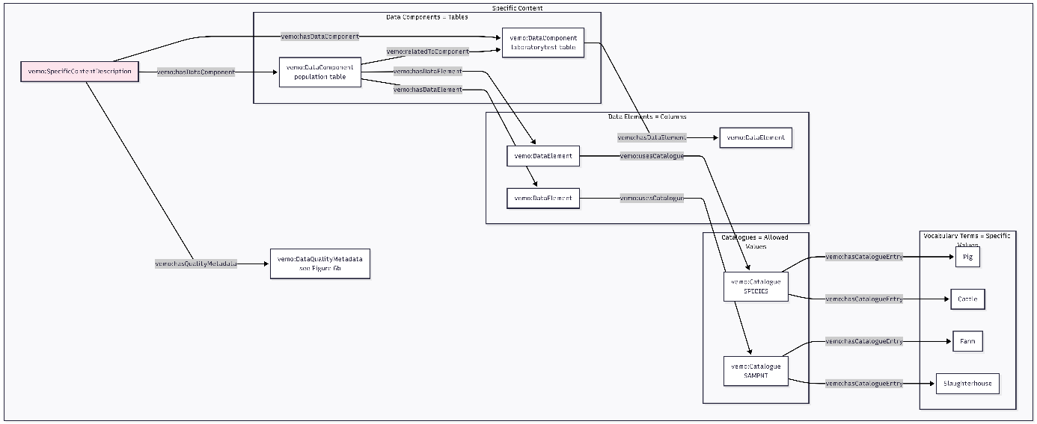Figure 6a: Properties of the Specific Content Description section of VEMO

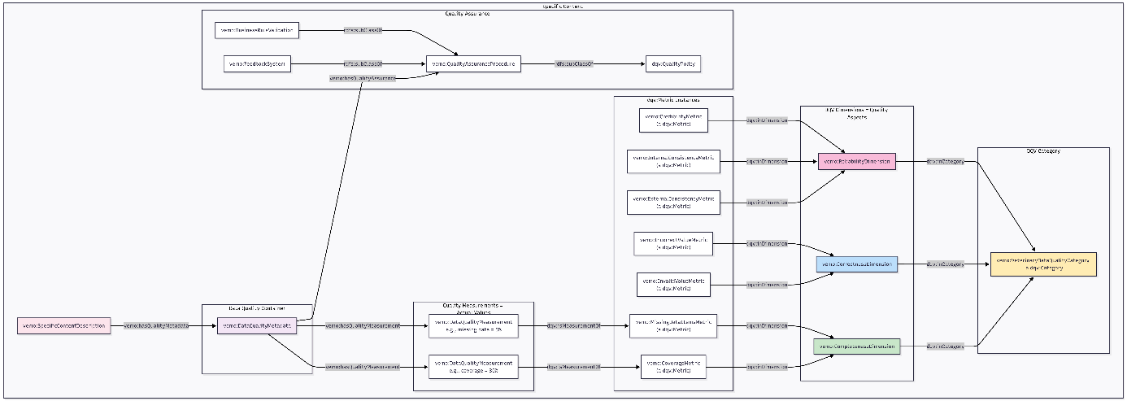Figure 6b: Properties of the Specific Content Description section of Vemo

Table 4: Mapping of the Properties associated with the Veterinary Data Quality Categories of VEMO
Quality Criteria | DQV Dimension | DQV Metric | Instance URI
Coverage | Completeness | CoverageMetric | vemo:CoverageMetric
Missing data items | Completeness | MissingDataItemsMetric | vemo:MissingDataItemsMetric
Invalid value | Correctness | InvalidValueMetric | vemo:InvalidValueMetric
Incorrect value | Correctness | IncorrectValueMetric | vemo:IncorrectValueMetric
External consistency | Reliability | ExternalConsistencyMetric | vemo:ExternalConsistencyMetric
Internal consistency | Reliability | InternalConsistencyMetric | vemo:InternalConsistencyMetric
Credibility | Reliability | CredibilityMetric | vemo:CredibilityMetric

